Photress

Use-Case Specification: Upload Photographies

Version <1.1>

Revision History

|  |  |  |  |
| --- | --- | --- | --- |
| **Date** | **Version** | **Description** | **Author** |
| 17.10.2013 | <1.0> | First version of Upload Photographies | Benny Görzig |
| 31.10.2013 | <1.1> | Added Mockup Added Narration | Benny Görzig |
|  |  |  |  |
|  |  |  |  |

Table of Contents

1. Upload Photographies 4

1.1 Brief Description 4

2. Flow of Events 4

3. Special Requirements 4

4. Preconditions 4

5. Postconditions 4

6. Extension Points 4

7. Mockup 5

8. Narration 6

Use-Case Specification: Upload Photographies Upload Photographies

# Upload Photographies

## Brief Description

The Use Case “Upload Photographies” is accessible for the actors “admin of own gallery” and “admin of hosted gallery”. The actor will be able to upload his photographies into the image pool of his account in order to make them accessible for his galleries.

# Flow of Events

# Special Requirements

N.a.

# Preconditions

The actor has to have an activated account and enough space for uploading the photographies into his image pool.

# Postconditions

The image pool of the actor contains the newly uploaded photographies.

# Extension Points

N.a.

# Mockup

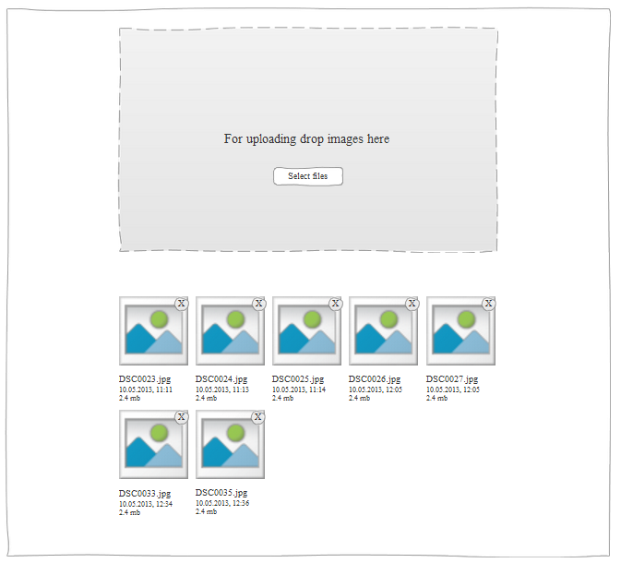

# Narration

Feature: upload photographies to my own account

As an registered user

I want to upload my photographies to my account

So I can view and share them later.

Scenario: upload a single photo "awesome_picture.png"

Given I am logged in

And I am a valid user

And I am on the "Upload images on my account"-page

When I click on the select image button

And I select the image "awesome_picture.png" on my storage

And I click ok

And I click upload

And the upload is finished

Then I should see a message which says "Successfully uploaded your picture awesome_picture to your account"

And the picture should have the filename

Scenario: upload multiple photos "awesome.png", "cool.jpg", "test.gif"

Given I am logged in

And I am a valid user

And I am on the "Upload images on my account"-page

When I click on the select image button

And I select multiple images on a storage

And I click ok

And I click upload

And the upload is finished

Then I should see a message which says "Successfully uploaded your pictures awesome, cool and test."

Scenario: upload multiple photos "awesome.png", "cool.jpg" and one invalid file "virus.exe"

Given I am logged in

And I am a valid user

And I am on the "Upload images on my account"-page

When I click on the select image button

And I select the images "awesome.png" and "cool.jpg" and the invalid file "virus.exe"

And I click ok

And I don't specifiy multiple image names

And I click upload

And the upload is finished

Then I should see a message which says "Successfully uploaded your pictures awesome and cool."

And I should see a message which says "But there was a problem with 'virus.exe' - It's an invalid file."